# **[Demo 26: How to use Arduino ESP32 I2S to play wav music file from sdcard](http://www.iotsharing.com/2017/07/how-to-use-arduino-esp32-i2s-to-play-wav-music-from-sdcard.html)**

1. **Introduction**  
   - ESP32 has two I2S peripherals. They can be configured to input and output sample data. They also supports [DMA](https://en.wikipedia.org/wiki/Direct_memory_access" \t "http://www.iotsharing.com/2017/07/_blank) to stream sample data without needing CPU operations. I2S output can also be routed directly to the Digital to Analog Converter output (GPIO25 and GPIO26) without needing [external I2S codec](https://vi.aliexpress.com/item/PCM5102-DAC-Decoder-I2S-Player-Assembled-Board-32Bit-384K-Beyond-ES9023-PCM1794-compatible-Raspberry-Pi/32678406932.html?spm=2114.55010608.4.2.jU683C" \t "http://www.iotsharing.com/2017/07/_blank).  
   - In this demo i will show you how to use Arduino ESP32 I2S to play **wav** music file from sdcard. I chose wav file because it is not compressed like mp3 file. So we need not to de-compress it.  
   - I used [external I2S codec](https://vi.aliexpress.com/item/PCM5102-DAC-Decoder-I2S-Player-Assembled-Board-32Bit-384K-Beyond-ES9023-PCM1794-compatible-Raspberry-Pi/32678406932.html?spm=2114.55010608.4.2.jU683C" \t "http://www.iotsharing.com/2017/07/_blank) for this demo, 2 speakers and 1 module [micro sdcard](http://www.iotsharing.com/2017/05/how-to-use-arduino-esp32-to-store-data-to-sdcard.html" \t "http://www.iotsharing.com/2017/07/_blank).

[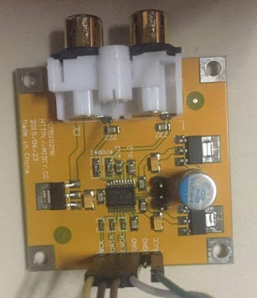](https://2.bp.blogspot.com/-0HAUwtfwAN0/WWIGfUgvaOI/AAAAAAAAEHU/a2L05ocwOsImQJHCxGt2H8q-ZDahPMfhgCLcBGAs/s1600/esp32_i2s_2.jpg)

**Figure: [external I2S codec](https://vi.aliexpress.com/item/PCM5102-DAC-Decoder-I2S-Player-Assembled-Board-32Bit-384K-Beyond-ES9023-PCM1794-compatible-Raspberry-Pi/32678406932.html?spm=2114.55010608.4.2.jU683C" \t "http://www.iotsharing.com/2017/07/_blank)**

[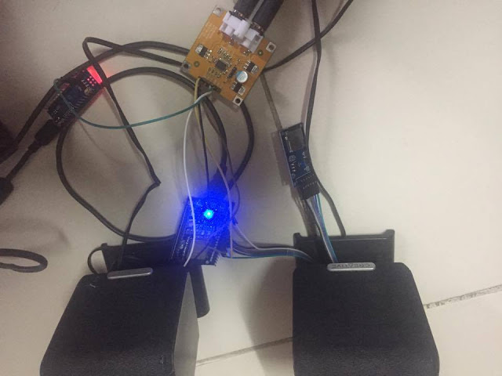](https://3.bp.blogspot.com/-zrYW161XJYY/WWIGgYKIxBI/AAAAAAAAEHY/_J9i7tJxQkwt6MBxSWFK-T8E_onIHoOYwCLcBGAs/s1600/esp32_i2s_1.jpg)

**Figure: I used [external I2S codec](https://vi.aliexpress.com/item/PCM5102-DAC-Decoder-I2S-Player-Assembled-Board-32Bit-384K-Beyond-ES9023-PCM1794-compatible-Raspberry-Pi/32678406932.html?spm=2114.55010608.4.2.jU683C" \t "http://www.iotsharing.com/2017/07/_blank) for this demo, 2 speakers and 1 module micro sdcard**

**2. Hardware**

Connect hardware like below:

[ESP32 IO32 – CS MICROSD]  
[ESP32 IO14 – MOSI MICROSD]  
[ESP32 IO12 – MISO MICROSD]  
[ESP32 IO27 – SCK MICROSD]  
[ESP32 IO26 – I2S codec BCK]  
[ESP32 IO22 – I2S codec DATA]  
[ESP32 IO25 – I2S codec LRCK]  
[ESP32 GND – I2S codec GND]  
[ESP32 GND – GND MICROSD]  
[5V – VCC MICROSD]  
[5V – I2S codec]  
**3. Software**  
- We will re-use [Demo 7](http://www.iotsharing.com/2017/05/how-to-use-arduino-esp32-to-store-data-to-sdcard.html" \t "http://www.iotsharing.com/2017/07/_blank) for sdcard reading and I2S driver [here](http://esp-idf.readthedocs.io/en/latest/api-reference/peripherals/i2s.html" \t "http://www.iotsharing.com/2017/07/_blank). You can download the document about the wav file format [here](http://tiny.systems/software/soundProgrammer/WavFormatDocs.pdf" \t "http://www.iotsharing.com/2017/07/_blank).  
**Note**: You can down full project including wav file sample : <https://github.com/nhatuan84/esp32-i2s-sdcard-wav-player>

|  |
| --- |
| #include <mySD.h>  #include "driver/i2s.h"  #include "freertos/queue.h"  #define CCCC(c1, c2, c3, c4) ((c4 << 24) | (c3 << 16) | (c2 << 8) | c1)  /* these are data structures to process wav file */  typedef enum headerState_e {  HEADER_RIFF, HEADER_FMT, HEADER_DATA, DATA  } headerState_t;  typedef struct wavRiff_s {  uint32_t chunkID;  uint32_t chunkSize;  uint32_t format;  } wavRiff_t;  typedef struct wavProperties_s {  uint32_t chunkID;  uint32_t chunkSize;  uint16_t audioFormat;  uint16_t numChannels;  uint32_t sampleRate;  uint32_t byteRate;  uint16_t blockAlign;  uint16_t bitsPerSample;  } wavProperties_t;  /* variables hold file, state of process wav file and wav file properties */  File root;  headerState_t state = HEADER_RIFF;  wavProperties_t wavProps;  //i2s configuration  int i2s_num = 0; // i2s port number  i2s_config_t i2s_config = {  .mode = (i2s_mode_t)(I2S_MODE_MASTER | I2S_MODE_TX),  .sample_rate = 36000,  .bits_per_sample = I2S_BITS_PER_SAMPLE_16BIT,  .channel_format = I2S_CHANNEL_FMT_RIGHT_LEFT,  .communication_format = (i2s_comm_format_t)(I2S_COMM_FORMAT_I2S | I2S_COMM_FORMAT_I2S_MSB),  .intr_alloc_flags = ESP_INTR_FLAG_LEVEL1, // high interrupt priority  .dma_buf_count = 8,  .dma_buf_len = 64 //Interrupt level 1  };    i2s_pin_config_t pin_config = {  .bck_io_num = 26, //this is BCK pin  .ws_io_num = 25, // this is LRCK pin  .data_out_num = 22, // this is DATA output pin  .data_in_num = -1 //Not used  };  //  void debug(uint8_t *buf, int len){  for(int i=0;i<len;i++){  Serial.print(buf[i], HEX);  Serial.print("\t");  }  Serial.println();  }  /* write sample data to I2S */  int i2s_write_sample_nb(uint32_t sample){  return i2s_write_bytes((i2s_port_t)i2s_num, (const char *)&sample, sizeof(uint32_t), 100);  }  /* read 4 bytes of data from wav file */  int read4bytes(File file, uint32_t *chunkId){  int n = file.read((uint8_t *)chunkId, sizeof(uint32_t));  return n;  }  /* these are function to process wav file */  int readRiff(File file, wavRiff_t *wavRiff){  int n = file.read((uint8_t *)wavRiff, sizeof(wavRiff_t));  return n;  }  int readProps(File file, wavProperties_t *wavProps){  int n = file.read((uint8_t *)wavProps, sizeof(wavProperties_t));  return n;  }  void setup()  {  Serial.begin(115200);  Serial.print("Initializing SD card...");  if (!SD.begin(32, 14, 12, 27)) {  Serial.println("initialization failed!");  return;  }  Serial.println("initialization done.");  delay(1000);  /* open wav file and process it */  root = SD.open("T.WAV");  if (root) {  int c = 0;  int n;  while (root.available()) {  switch(state){  case HEADER_RIFF:  wavRiff_t wavRiff;  n = readRiff(root, &wavRiff);  if(n == sizeof(wavRiff_t)){  if(wavRiff.chunkID == CCCC('R', 'I', 'F', 'F') && wavRiff.format == CCCC('W', 'A', 'V', 'E')){  state = HEADER_FMT;  Serial.println("HEADER_RIFF");  }  }  break;  case HEADER_FMT:  n = readProps(root, &wavProps);  if(n == sizeof(wavProperties_t)){  state = HEADER_DATA;  }  break;  case HEADER_DATA:  uint32_t chunkId, chunkSize;  n = read4bytes(root, &chunkId);  if(n == 4){  if(chunkId == CCCC('d', 'a', 't', 'a')){  Serial.println("HEADER_DATA");  }  }  n = read4bytes(root, &chunkSize);  if(n == 4){  Serial.println("prepare data");  state = DATA;  }  //initialize i2s with configurations above  i2s_driver_install((i2s_port_t)i2s_num, &i2s_config, 0, NULL);  i2s_set_pin((i2s_port_t)i2s_num, &pin_config);  //set sample rates of i2s to sample rate of wav file  i2s_set_sample_rates((i2s_port_t)i2s_num, wavProps.sampleRate);  break;  /* after processing wav file, it is time to process music data */  case DATA:  uint32_t data;  n = read4bytes(root, &data);  i2s_write_sample_nb(data);  break;  }  }  root.close();  } else {  Serial.println("error opening test.txt");  }  i2s_driver_uninstall((i2s_port_t)i2s_num); //stop & destroy i2s driver  Serial.println("done!");  }  void loop()  {  } |